# CIS7 Lab 8: Sequence and Series in C++

## Arithmetic Sequence

An **arithmetic sequence** is a sequence in which **each term equals the preceding term** **plus a constant**.

In an arithmetic sequence, **the difference between consecutive terms is always the same**.

**t(n) = a + (n − 1)d**

1. Given an Arithmetic Sequence: 2, 5, 8, 11, 14, ….

In this sequence 2 is the stating term of the series. Common difference = 5 – 2 = 3 (Difference common in the series), so we can write the series as:

t(1 )= a

t(2) = a + (2-1) * d

t(3) = a + (3-1) * d

t(N) = a + (N-1) * d

**Example 1:** A C++ program to determine the Nth term in arithmetic progression, where N = 5.

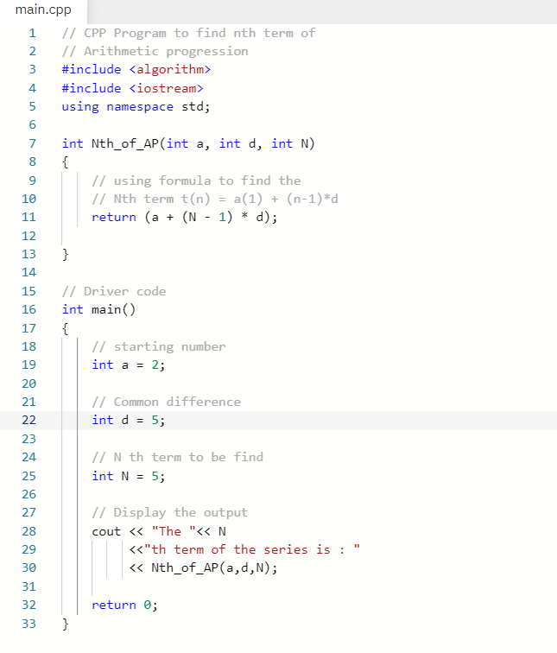

1. Write and run Example 1 program in IDE. Provide screen capture of code and output.
2. Calculate the nth term for the above program using **t(n) = a + (n − 1)d**. Provide the initial the initial sequence from the 1st to 5th term. Verify if the program output is accurate.

A = 2, d = 5

T (1) = 2 + (1-1) * 5 = 2

T (2) = 2 + (2-1) * 5 = 7

T (3) = 2 + (3-1) * 5 = 12

T (4) = 2 + (4-1) * 5 = 17

T (5) = 2 + (5-1) * 5 = 22

1. Using the above formula for Arithmetic Progression to find t(n) where n = 20. Show calculation below.

T (20) = 2 + (20-1) * 5 = 97

1. Edit the program the output value of the 20th term in the sequence. Does your calculation from # 1B match the program output? If it does not match, provide explanation why the results are different.

It Matches

1. Edit the program using a different arithmetic sequence: 1, 8, 15, 22, 29…. Determine the value for 15th term. Provide screen capture of program code and output.

A = 1, d =7, N = 15

T (15) = 99

1. In #1D, what is the value of a? What is the value of d? What is the value of the 15th term?

A = 1, d = 7, n = 15

T (15) = 99

## Arithmetic Series

A **series** is a sum of the terms of a sequence.

An **arithmetic sum** is a sum of terms of an arithmetic sequence.

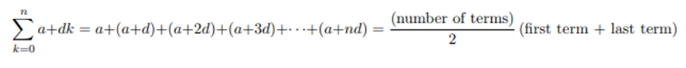

**Example 2**: A C++ program that calculates the sum of an arithmetic sequence:

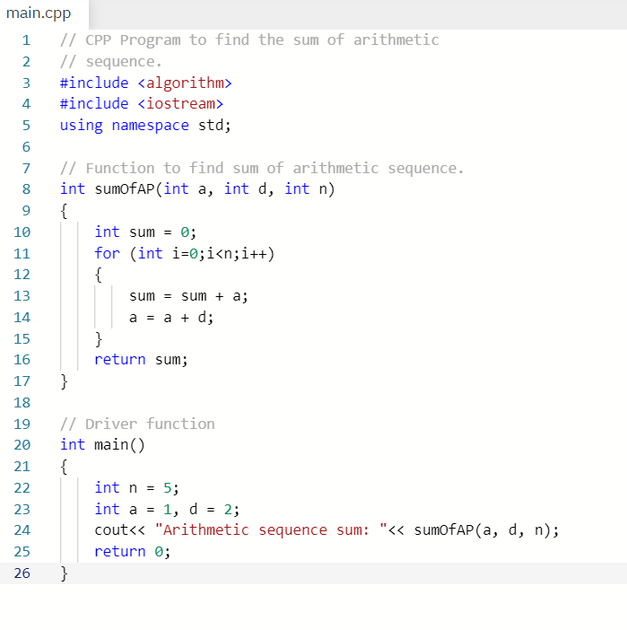

1. Write and run program in an IDE. Provide screen capture of code and output.

1. Provide the initial part of the arithmetic sequence, up to the 5th term, for Example 2 program.

A = 1, d = 2, n = 5

T (1) = 1 + (1-1) * 2 = 1

T (2) = 1 + (2-1) * 2 = 3

T (3) = 1 + (3-1) * 2 = 5

T (4) = 1 + (4-1) * 2 = 7

T (5) = 1 + (5-1) * 2 = 9

1. Use Gauss’ Trick formula to verify that the output of the program. Show your computation below.

First Term = 1, Last Term = 9, N = 5

Sum = $\frac{5}{2}\left(1+9\right)=\frac{50}{2}=25$



1. Edit program calculate the sum of another sequence: 4, 14, 24, 34, 44,…

**Determine the partial sum** for the above sequence, in which N = 30. Provide screen capture and code.

A = 4, D = 10, N = 30

T (30) =

**Example 3**: The below C++ program illustrates how a sequence can be derived from user input of the starting value, difference and term (N).

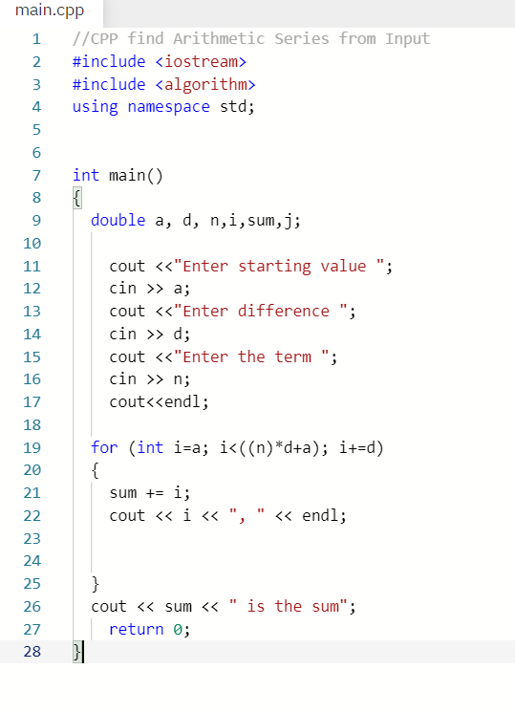

1. Write and run Example 3 program in IDE using starting term = 3, difference = 6, and term or N is 10. Provide screen capture of code and output.

1. Use formulas to determine the arithmetic sequence and sum, given that starting term, a = 3, difference or d = 6, and term or N = 10.

A = 3, D = 6, N = 10

T (1) = 3 + (1-1) * 6 = 3

T (2) = 3 + (2-1) * 6 = 9

T (3) = 3 + (3-1) * 6 = 15

T (4) = 3 + (4-1) * 6 = 21

T (5) = 3 + (5-1) * 6 = 27

T (6) = 3 + (6-1) * 6 = 33

T (7) = 3 + (7-1) * 6 = 39

T (8) = 3 + (8-1) * 6 = 45

T (9) = 3 + (9-1) * 6 = 51

T (10) = 3 + (10-1) * 6 = 57

Sum = $\frac{10}{2}\left(57+3\right)=300$

1. Explain the implementation of the equation in Example 3 program.

User is prompted to input a starting value, difference, and number of terms in the series. It then uses an iterative approach by using a for loop which starts at the starting value and increments by the difference each iteration. Each iteration the iterator is added to the final sum. This final sum is output.

## Geometric Sequence and Series

In a Geometric Sequence each term is found by multiplying the previous term by a constant. We write a Geometric Sequence like this: {a, ar, ar2, ar3, ... } where a is the first term, and r is the factor between the terms (called the "**common ratio**").

To calculate any term: **T(n) = ar(n-1)**, we use "n-1" because ar0 is for the 1st term.

To sum geometric sequence: a + ar + ar2 + ... + ar(n-1)

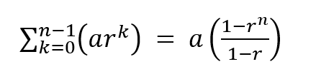

**Example 4:** C++ program that performs sum of geometric sequence.

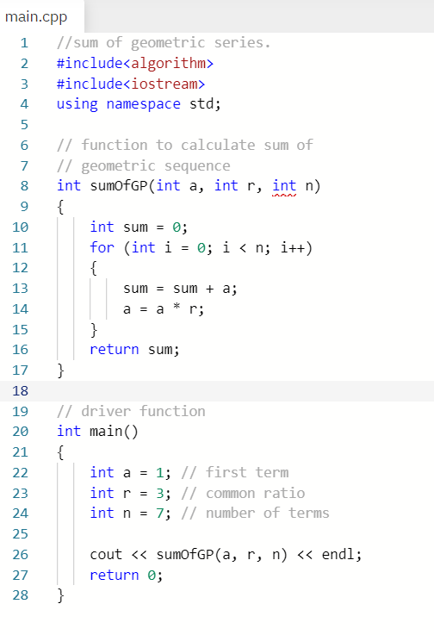

1. Write and run Example 4 program in an IDE. Provide screen capture of code and output.

1. Determine the geometric sequence and sum based on the given values in Example 4 program.

A = 1, R = 3, N = 7

Sum = $1\left(\frac{1-3^{7}}{1-3}\right)=1093$

1. Modify the program using a = 2, r = 1/4, n = 8. Run the program and provide screen capture of code and output. *Note: Remember to check data type when edit the program!

1. Use the equations and determine the geometric sequence and sum for #4B.

T (1) = $2*{\left(\frac{1}{4}\right)}^{1-1}=2$

T(2) = $2*{\left(\frac{1}{4}\right)}^{2-1}=0.5$

T(3) = $2*{\left(\frac{1}{4}\right)}^{3-1}=0.125$

.

.

.

T(8) = $2*{\left(\frac{1}{4}\right)}^{8-1}=0.0001220703125$

Sum = $2*(\frac{1-{\left(\frac{1}{4}\right)}^{8}}{1-\frac{1}{4}}$) = 2.666

1. Explain the algorithm of the program.

The sumOfGP function takes in three parameters (a, r, and n). A sum variable is created and initialized to 0. A for loop is used to iteratively add to the sum. Each iteration sum is first incremented by the value of A. After A is set to a new value created by multiplying itself by the common ratio R. This new A value is carried over to the next iteration of the loop where it is then added to the sum. After the loop has iterated n times we return sum to be printed.